CS332: Distributed Computing
Lab 01: Multithreaded Programming
Program: BS Computer Science
Course Code: CS332
Lab Title: Multithreaded Programming
Student Name: Abrar Butt
Qalam Id: 460297
Section: C

Instructor: Dr. Khurram Shahzad / Dr. Shah Khalid

Lab 01: Multithreaded Programming

Introduction
This lab is designed to revise the concepts of multithreaded programming.
Objectives
Analyze the execution time of single thread and multi-thread program.
Tools/Software Requirement
MS Visual Studio 2013 Or any other programming language
Description
About Threading
Threading is a lightweight process. With the help of threads, we can decrease the processing
time of the application. To use multithreading, we have to use the Threading namespace which
is included in System. The System.Threading namespace includes everything we need for multi-
threading.

Lab Tasks
Q1: Below is the C code to calculate pi, it took 1000 microseconds to calculate and display the
calculated value. Your task is as follows:
- Convert the following C code into C# or Java and calculate the execution time.
- Convert your C# /Java code into multithreaded version and analyze the execution time.
- Is it better to use multithreaded version compared to single threaded in PI
calculation?
Question 1 ANS:
Code:
Ln: java:
public class SingleThreadPI {

public static void main(String[] args) {
long startTime = System.nanoTime();

int iterations = 100_000_000;
double pi = 0.0;
double sign = 1.0;

for (int i = 0; i < iterations; i++) {
pi += sign / (2.0 * i + 1.0);
sign = -sign;
}

pi *= 4;

long endTime = System.nanoTime();
double executionTime = (endTime - startTime) / 1_000_000.0;

System.out.println("PI (Single Thread) = " + pi);
System.out.println("Execution Time = " + executionTime + " ms");
}
}

Output:
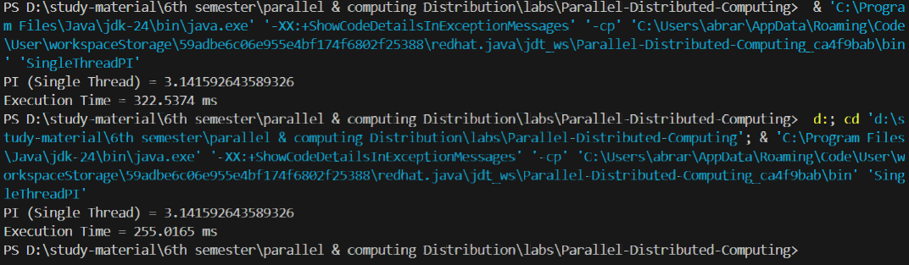
Question 2 ANS:
Code:
Ln: java
class PiThread extends Thread {
private int start, end;
private double result = 0.0;

public PiThread(int start, int end) {
this.start = start;
this.end = end;
}

public void run() {
double sign = (start % 2 == 0) ? 1.0 : -1.0;

for (int i = start; i < end; i++) {
result += sign / (2.0 * i + 1.0);
sign = -sign;
}
}

public double getResult() {
return result;
}
}

public class MultiThreadPI {

public static void main(String[] args) throws InterruptedException {
long startTime = System.nanoTime();

int iterations = 100_000_000;
int mid = iterations / 2;

PiThread t1 = new PiThread(0, mid);
PiThread t2 = new PiThread(mid, iterations);

t1.start();
t2.start();

t1.join();
t2.join();

double pi = 4 * (t1.getResult() + t2.getResult());

long endTime = System.nanoTime();
double executionTime = (endTime - startTime) / 1_000_000.0;

System.out.println("PI (Multi Thread) = " + pi);
System.out.println("Execution Time = " + executionTime + " ms");
}
}

Output:
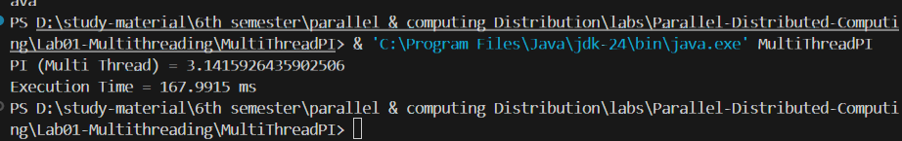
Question 3 ANS:
Yes, the multithreaded version is more advantageous for calculating PI in case the number of iterations is large, and the system supports more than one CPU core. This decreases execution time by parallelizing computation. In contrast, single-threaded execution could be more efficient for small tasks because it has less overhead.

Note:
To calculate Time, you can use following code or google any other library.
using System.Diagnostics;
Stopwatch stopWatch = new Stopwatch();
stopWatch.Start();
stopWatch.Stop();
TimeSpan ts = stopWatch.Elapsed;
string elapsedTime = String.Format(&quot;{0:00}:{1:00}:{2:00}.{3:00}&quot;,
ts.Hours, ts.Minutes, ts.Seconds,
ts.Milliseconds / 10);
Console.WriteLine(&quot;RunTime &quot; + elapsedTime);

Deliverables
Compile a single word file and upload on LMS.

